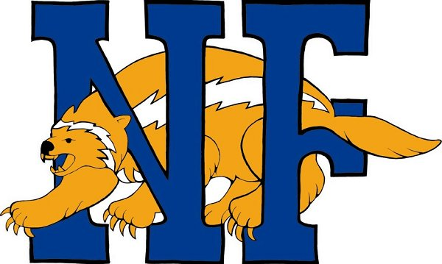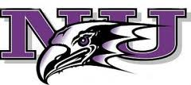
Niagara Falls City School District
Early College High School
Why Join ECHS???

- You have the opportunity to earn up to 24 college credits at no cost to you! (A value of $25,000.00)

- You will be part of a select group of students at NFHS to have this opportunity

- You will open up opportunities for yourself with college scholarships and highly acclaimed colleges and universities

- NU course credit may be transferable to other colleges and universities.

- You will receive mentoring/tutoring throughout the four year program to help you be more successful academically

- You will be able to participate in campus events at Niagara University

- Career assessments will be performed to determine your career interests

- You will take classes that will give you a solid foundation in the core curriculum areas for college entry

- You will have the opportunity to attend college classes on campus with college students at NU

- Upon registering for college courses, you will be given a Niagara University ID card so you can gain access to the Kiernan Center, library, computer labs, and other campus amenities

